Subject: Geology, Marine Science, Geography

Lesson Topic: Benthic Geology

Author: Erin Spruill

Grade Level: 9-12

Summary of Activity/Lesson: This lesson will introduce your students to marine geology using sediment samples from Onslow Bay and the Cape Fear River Plume. Although the maps and samples are specific to the North Carolina coast, you can adapt the basic principles to your region. In addition to looking at the marine geology, this inquiry based lesson can serve as companion/precursor to other topics such as benthic flora/fauna or coastal processes. Feel free to pick and choose the activities or use them all as one lab session.

Activity:

Materials:

- Large laminated map with depth, longitude, and latitude specific to area of interest
- Small notebook size map (specific to sediment samples) for each student (you can laminate so students can use for several activities throughout the year)(an example is included)
- Wax pencils or erasable markers (if you choose to laminate)
- Color pencils/markers/crayons
- Map coordinates of soil sample sites (example shown below)
- Soil samples from CORMP mooring and cruise sites (contact us at www.cormp.org OR collect local samples)
- Prepared sediment slides
- At least 2 microscopes
- Geotechnical gauge (or some resource with geological information about sediments like color, particle size, etc.) you can buy these online for between $13 and 15.50 plus tax. If you choose to print them out, have students color them and add sediment samples as a pre-lab/end of class activity.
- Plastic Petri dishes for sediment
- Metal spatulas or plastic pipettes
- Rulers
- Handout for students (overhead or on the board or on paper)

Making mud fun!!!
- Explore first and explain later
  - It’s all in a name – don’t let the lesson title give it all away (e.g. “Benthic Geology” or “Marine Geology”)
  - Explain only what is necessary – (e.g. just make sure students know how the stations will flow and time constraints that they have to complete the activity)
- Lesson Flow
  - This lesson is designed as an inquiry station lab.
  - Students will be presented with a picture of two different sediment samples either (Ideally on power point so whole class can do this part at the same time. If this isn’t possible print several color copies of two sediment samples or have several sets of actual samples in class to pass around) (an example photo is included)
  - Without providing any prior knowledge, ask students to record observations about the samples and write down a guess as to why they are different or the same. Make sure you let them know there are no wrong answers.
  - Then students will have 60 minutes for 4 stations
  - Stations are as follows:
* Students can go in any order and even revisit a station. However, let students know an approximate time for each station.
* Each station covers broad themes. Teachers can design handout as they please or adapt the one provided.
1. Physical Characteristics of Sediment
- Students will record data about the physical characteristics of 2 sediment samples they examine in vials and under the microscope.
- They answer the same questions about 2 samples.
- Provide vials of the two samples you are comparing.
- Have microscopes set up with slides/lenses already prepared with the two samples.
- Biogenesis and lithogenesis will be indirectly introduced.
2. Plotting out sample locations
- The coordinates of the sample locations will be listed and the students will have to plot them and label them on their own map handout. They will have to construct a key.
- They will also have to list the depth of the station by looking around the markers on the map.
- Provide sediment samples that the students can arrange after they map out the points. They will use these arranged sediments to make more observations.
3. Geotechnical cards and Microscope
- here there will be numbered Petri dishes with sediment and the students will use the Geotechnical Gauge cards to determine what kinds of sediments is present, USCS classification, etc.
- There will also be microscopes with prepared slides of same samples for students to really look closely at the make up of the sediments.
- Students will need to record data and note which sample they are describing.
4. Benthic profile
- Students will be asked to look at transect lines on a map and make a chart showing the slope of a coastline.
- Students will also have to draw some conclusions about state of sediments along this progression.
- Have a map on affixed to the wall.
- Make a line from the coast to offshore (either some straightedge taped or draw the line if it is laminated.
- Conclusion
  - After students have completed all the stations, they will refer to the board/overhead for their final task
  - The final question is to be answered on their handout. Hopefully the activities will serve to tie everything they did together. Ask students to…
- Restate their hypothesis based on the data they have collected
- Did they change their guess? Why or why not?
- What factors do they think are involved in the processes they have observed? What data did they collect to support their ideas
  - After everyone has finished discuss their findings and try to point out trends, patterns, etc. I recommend having a sheet of questions you want to ask before class.
- Overall….make sure you are floating around checking on students as they travel through the stations. Sometimes these activities will encourage students to get off task…so keep involved with them.
- If you know that one activity is especially difficult, then make sure you check on each new group of students that passes through.

Sample Materials

NAME:
DATE:
PERIOD:

MUD PIE MADNESS

Get ready to rock and roll and we get down and dirty and dig through this activity. Today you will be working in 4 stations, making observations, playing with dirt, and looking at maps. Please remember that the only wrong answer is NO answer. Be careful…..you just might learn something. ☺

- See up front:

Please complete the following questions as you work through the 4 stations in any order you please. You have 60 minutes to finish, so use your time wisely. Ask me if you have any well thought out questions.

BLUE STATION: The Nitty Gritty
- Examine a white-capped tube and the matching sample under the microscope:
  - Have you seen this sediment before? Where?

  - What color(s) is the sediment?

  - How would you describe the particles?

  - How big are the particles?

  - Shake the tube, what happens to the contents?

  - If you were to rub this sediment on your skin, how do you think it would feel?

  - Based on your observations, guess what coastal processes formed this
sediment.

- Examine a black-capped tube and the matching sample under the microscope:
  - Have you seen this sediment before? Where?

  - What color(s) is the sediment?

  - How would you describe the particles?

  - How big are the particles?

  - Shake the tube, what happens to the contents?

  - If you were to rub this sediment on your skin, how do you think it would feel

  - Based on your observations, guess what coastal processes formed this sediment.

Using your observations of both sediment vials, look at the color map of the CORMP sample sites. Where do you think each sediment tube originated? Why?

YELLOW STATION: Where am I?
- Take the coordinates and plot them on your map handout. Be sure to design a key so you know which station is which.

Station # | Location | Designation
UNCW Center for Marine Science | 34° 8.5’ N 77°51.7’ W | CORMP Home!!
OBSM | 34° 10.5’ N 77° 47.9’ W | river channel
OB5 | 34° 08.4’ N 77° 42.9’ W | coastal ocean
OB10 | 34° 06.2’ N 77° 37.5’ W | coastal ocean
OB15 | 34° 03.9’ N 77° 32.0’ W | coastal ocean
OB20 | 34° 01.8’ N 77° 26.7’ W | coastal ocean
OB27 | 33° 59.6’ N 77° 21.2’ W | mid-shelf
CFP-1 | 33° 53’ N 78° 00’ W | lower estuary
CFP-2 | 33° 50’ N 78° 02’ W | river mouth
CFP-6 | 33° 52’ N 78° 05’ W | river plume
CFP-7 | 33° 50’ N 78° 06’ W | river plume
CFP-5 | 33° 53’ N 78° 08’ W | river plume
CFP-4 | 33° 48’ N 77° 59’ W | coastal ocean
CFP-3 | 33° 48’ N 78° 05’ W | coastal ocean
CFP-8 | 33° 53’ N 78° 10’ W | plume(?)
CFP-9 | 33° 47’ N 78° 14’ W | plume(?)

- Now look at the samples in the plastic bins. Arrange them on your map according to their label. Do you notice any patterns?

- What do you think the sediment at OB63M will look like? Why?

- How will it compare to OB5?

- Are there differences or similarities in the OB and the CFP samples? What are they?

6. What do you think the numbers (ex. OB5) indicate?

RED STATION: A Closer Look
- Examine the contents of each Petri dish.
- Use the Geotechnical Gauge to record data about each sample in the following table

Petri Dish | Color (s) | Grain Size | Sieve Size | Texture | Particle Shape

- Look at each slide under the microscope and draw and color a picture of what you see. Then describe what you see beside each circle.

DRAW DESCRIBE

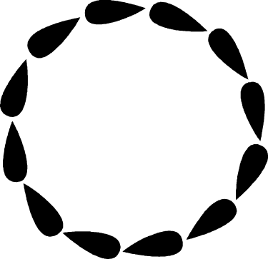

PINK STATION: Under the Sea
- Starting Howell’s Point, record depth every ½ inch until you reach a depth of 40 feet.
- Then record depth every 5 inches.

Draw a table showing your markers and the depth at each marker.

Use your data to make a chart that shows the ocean floor from shore to open water starting at Howell’s Point and ending with your last depth measurement.

DRAW YOUR CHART HERE: Be sure to label depth (y-axis), your inch markers (x-axis), and connect your data points to roughly diagram the ocean floor. **Make sure you carefully plot your points along the x-axis......ask me if you need further clues.

- How many feet are in a meter?

- How many feet are in a fathom?

- How many meters are in a fathom?

- Why do we have so many ways of measuring depth?

- Look at your chart tell me briefly (1-2 sentences) what sediment will look like as you go from on-shore to off-shore.

- How far from shore is your last marker?

- Try to incorporate the information from #5 into your graph

ONCE YOU FINISH THE ENTIRE ASSIGNMENT,
LOOK UP FRONT FOR YOUR FINAL CHALLENGE!!!!!!!!!!

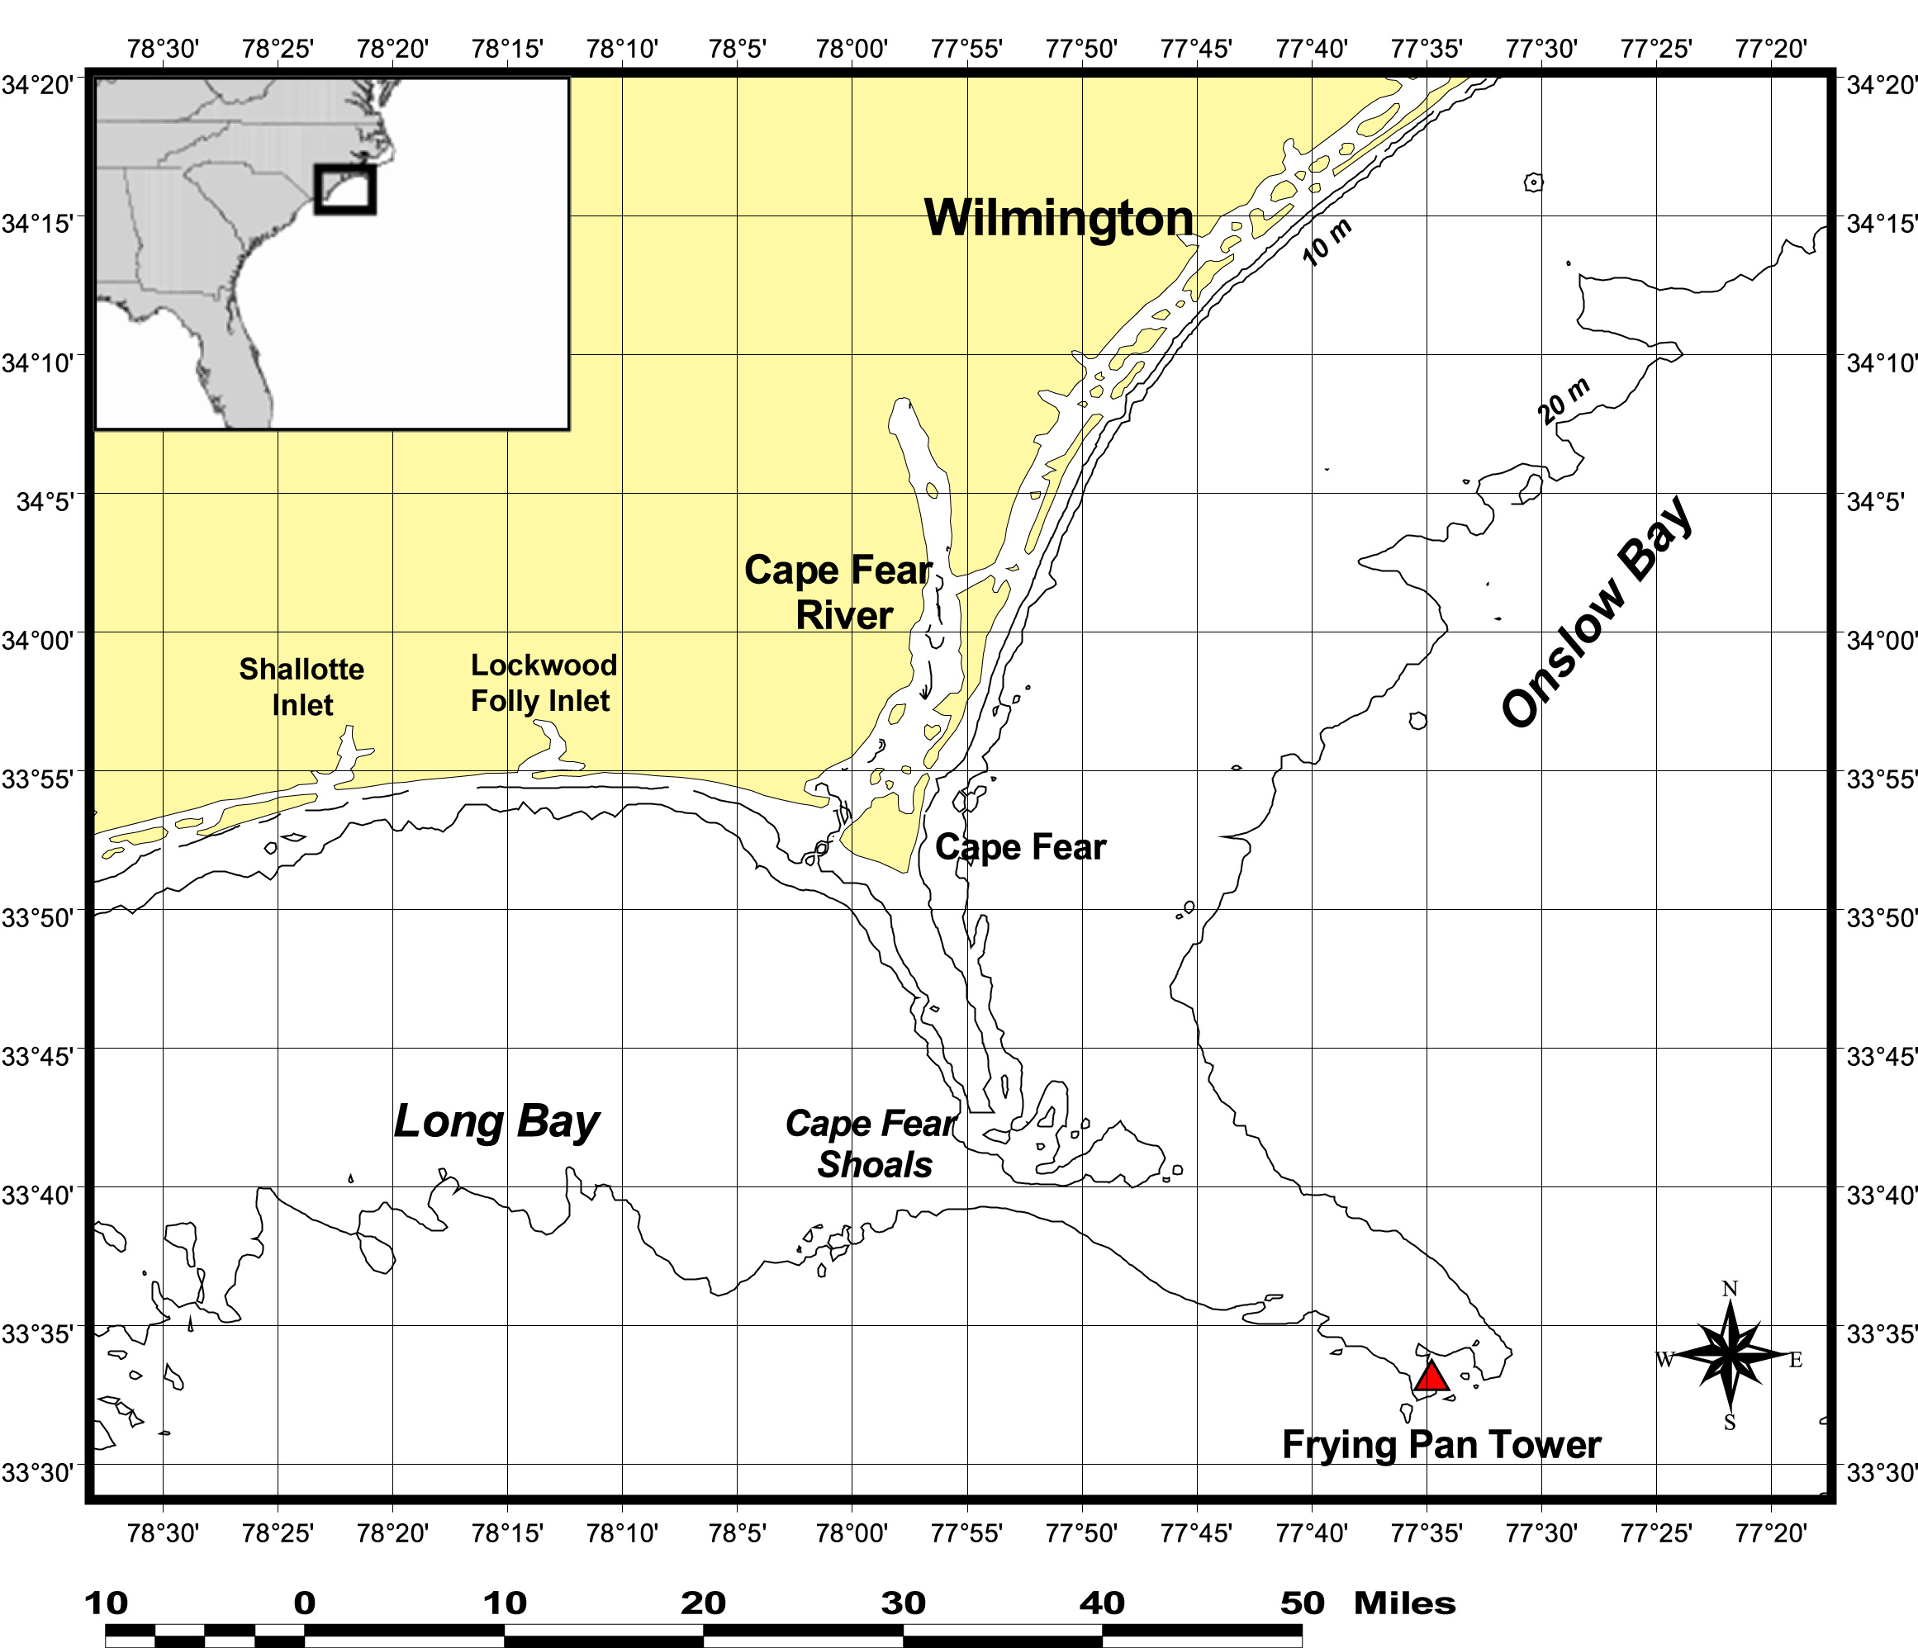

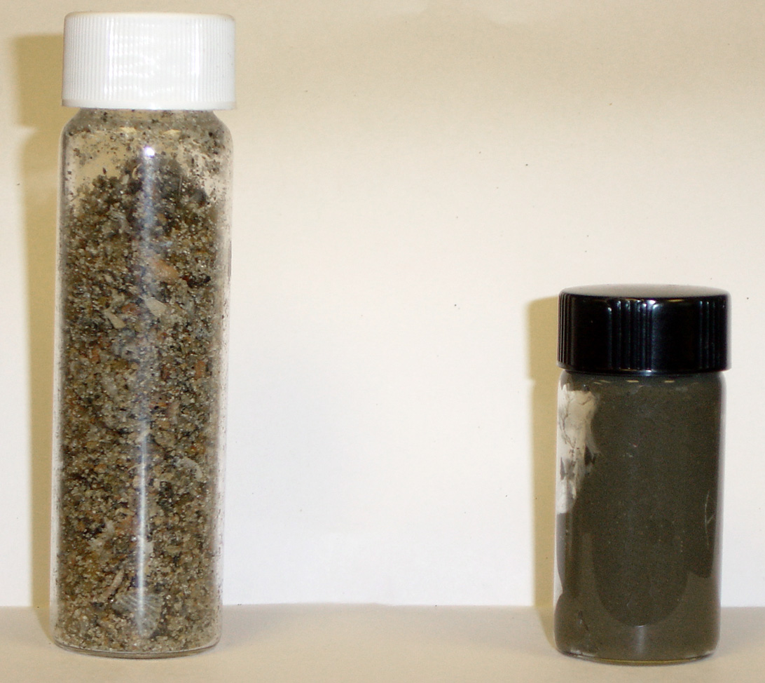

This picture is to be displayed at the front of the room or made available in some other fashion for the initial comparison indicated on the worksheet.

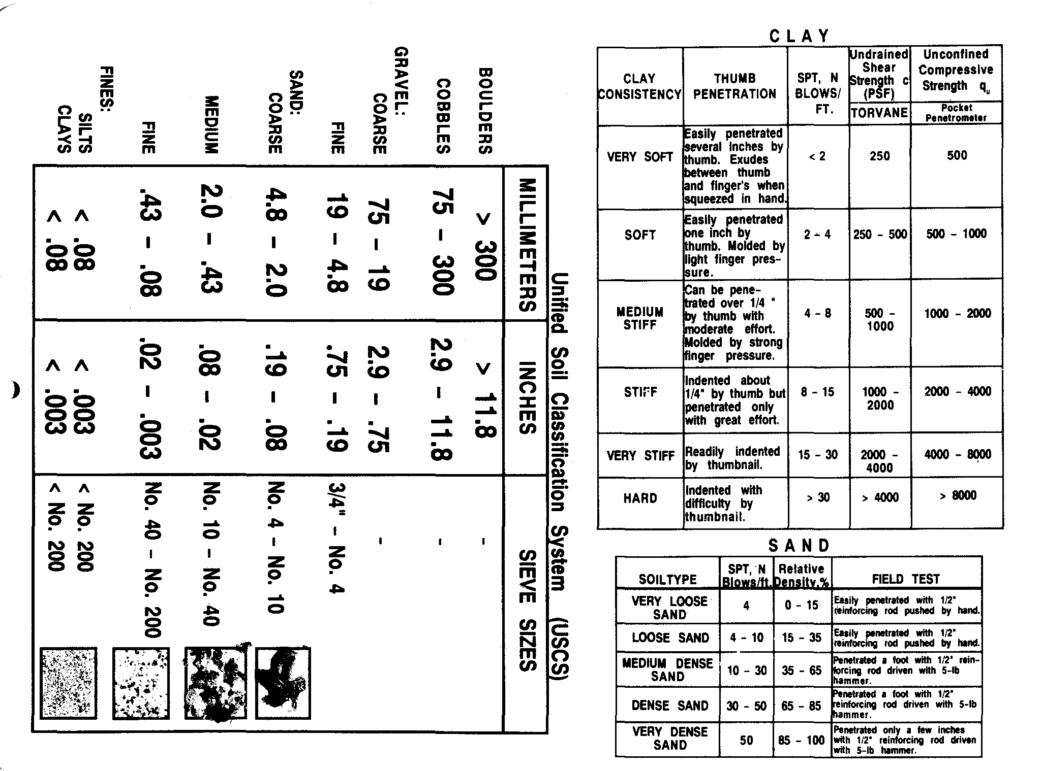
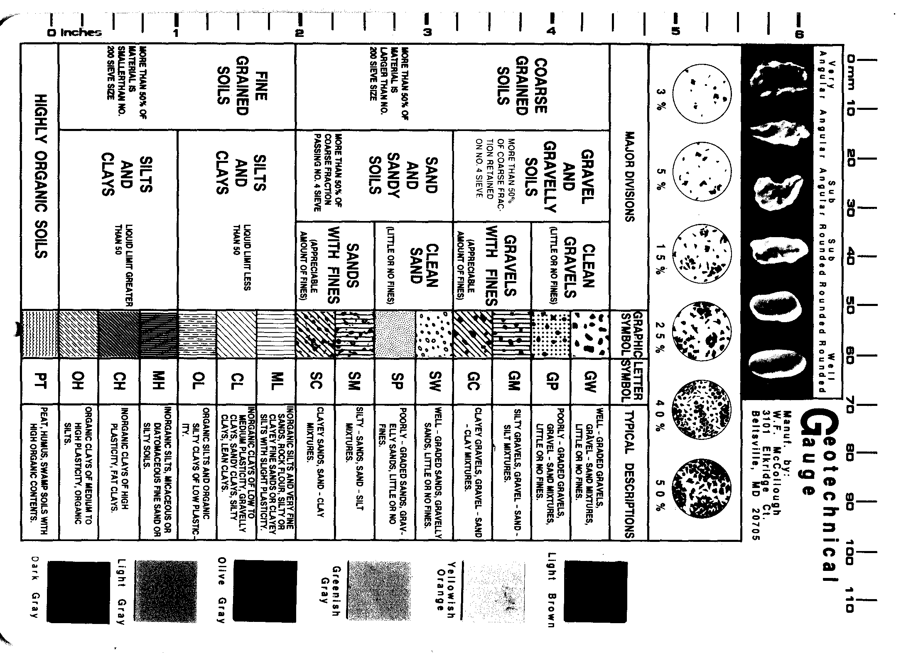
Disclaimer: These lesson plans were compiled, edited, written, and/or prepared by Erin Spruill, UNCW Coastal Ocean Research and Monitoring Program (CORMP). CORMP is a NOAA grant funded program, located at the UNCW Center for Marine Science, Wilmington, NC. Feel free to update or adapt the existing lesson plans to fit your needs. We ask that you credit the authors and editors of these activities. In addition, please contact us with new methods and activities you implement in the classroom. Continual collaboration and revision will allow us to provide educators with the most useful and current resources for classroom use. Thank you.

